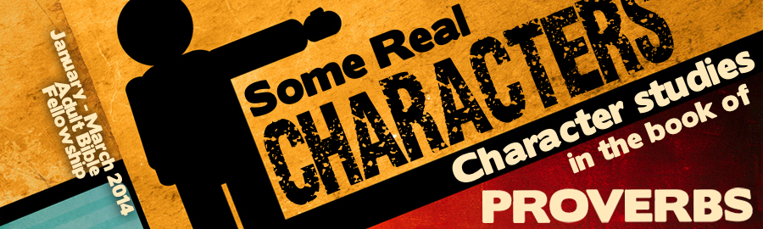
LESSON 9: “Poor Man” Date:
KEY VERSE: Proverbs 21:13 – “Whoso stoppeth his ears at the cry of the poor, he also shall cry himself, but shall not be heard.”
INTRODUCTION
The problem with poverty is not new and is not going away. Jesus said, “The poor always ye have with you” (John 12:8). Just because the war on poverty will not be won does not mean that we should be unconcerned about the condition of the less-fortunate.
Poverty is mentioned times in the book of Proverbs. In fact, the authors of Proverbs use several different Hebrew words to picture the plight of the poor. While all of the words referring to the poor in Proverbs relate to those in the lowest social class, the primary pictures presented by the Hebrew words translated, “poor,” or “poverty” in Proverbs are these:
- A needy person driven to a desire for relief (Prov. 14:31b). This word specifically refers to a beggar (Prov. 30:14; 31:9, 20)
- A person who is or bent low (Prov. 10:15; 14:31; 19:4; 21:13; 22:9,16; 22:22; 28:3,8,11,15; 29:7,14)
- To possess or to be (Prov. 20:13; 23:21; 30:9); an inheritance gained or lost
- To be by affliction (Prov. 3:34; 14:21; 16:9)
The sad fact of class warfare is made very clear in the book of Proverbs (Prov. 14:20; 19:7). The poor are frequently despised by the rich. God wants us to have wisdom regarding poverty and riches.
REASONS FOR POVERTY
While the problem of poverty is evident and solutions for the problem are constantly suggested, the book of Proverbs speaks specifically to the reason why some are poor.
- (Prov. 6:6-11) — The average American will spend years of their life watching television!
- (Prov. 21:20; 11:24)
- (Prov. 23:21)
- (Prov. 23:21) — One of the few prejudices tolerated today is the prejudice against the obese.
- (Prov. 28:22)
- (Prov. 13:18) — You cannot move up in the world without a teachable spirit!
- Lack of (Prov. 21:13; 22:16; 28:27)
- Lack of (Prov. 28:19) — Five minutes with the wrong friend can lead to a lifetime of poverty.
THE TREATMENT OF THE POOR
The well-being of the wise will be greatly impacted by their treatment of the poor. Those who treat the poor well are promised blessings and those who treat the poor cruelly will suffer.
Proper treatment of the poor will lead to blessings.
- (Prov. 14:21)
- God (Prov. 14:31)
- Assurance of (Prov. 19:17; 22:9; 28:27)
- Increased opportunity for (Prov. 29:14)
Improper treatment of the poor will lead to sorrow.
- Improper treatment of the poor is a (Prov. 14:31; 17:5).
- Improper treatment of the poor brings (Prov. 21:13; 22:16).
- Improper treatment of the poor brings loss of (Prov. 28:15).
THE TRUTHS ABOUT POVERTY
- Poverty may cause (Prov. 10:14).
- Poverty may cause (Prov. 18:23).
- Poverty may cause (Prov. 22:7).
- Poverty may tempt one to (Prov. 30:8-9).
- Poverty is better than (Prov. 19:22).
- Poverty is better than (Prov. 28:6).

