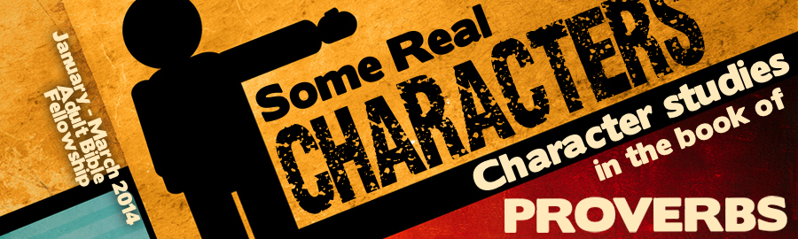
LESSON 8: “I Wish I Were A Rich Man” Date:
KEY VERSE: Proverbs 14:24 – “The crown of the wise is their riches.”
INTRODUCTION
When the topic of money is broached, people become very sensitive. Everyone has an opinion. Some Christians almost seem to believe that it’s a sin to be wealthy. Other believers seem to believe that it’s a sin to be poor. Unfortunately, many Christians never take the time to really consider what the Bible has to say about the matter of wealth.
By any standard, Americans are extraordinarily wealthy people. Christians who live in America need to learn to balance the fact that “The love of money is the root of all evil” (I Tim. 6:10) with the fact that, “The crown of the wise is their riches” (Prov. 14:24).
The book of Proverbs presents a striking contrast between the rich and the poor and provides counsel for both. Let’s give careful attention to the rich man in the book of Proverbs.
TRUTHS ABOUT THE RICH
The book of Proverbs shares several stereo-typical characteristics of the wealthy. These character traits cross both generations and cultures.
- The rich are often (Prov. 18:23). —Because rich people are so often unkind, its noteworthy to find those who are both wealthy and courteous.
- The rich are often (Prov. 19:40).
- The rich rule over the (Prov. 22:7). — This truism is evident the world-over.
INSTRUCTIONS FOR THE RICH
The book of Proverbs clearly presents the characteristics of those who would attain riches. These instructions present a God-inspired path from poverty wealth and should be considered carefully.
- The rich are (Prov. 10:4). — Riches come to those who work and flee from those who don’t!
- The rich are (Prov. 11:16). — Tyrants often control treasures. Those who would be rich righteously must depend upon God as their strength.
- The rich are (Prov. 14:24). — Wealth is an evidentiary indicator of wisdom.
- The rich are (Prov. 21:17). — Spenders become paupers.
- The rich are (Prov. 22:4). — In what way is this true?
- The rich are (Prov. 22:4).
- The rich are (Prov. 28:20).
WARNINGS TO THE RICH
Money talks—it often says, “Good-bye!” The Bible is filled with warnings for those who would be rich. Here are some of the warnings found in the book of Proverbs:
- Riches bring no in judgment (Prov. 11:4). — Our God is no respecter of persons (Rom. 2:11).
- Riches gained without labor will (Prov. 13:11).
- Riches tend to make a person feel (Prov. 18:11).
- Riches may be (Prov. 23:5).
- Riches found quickly tend to be riches found (Prov. 28:20).
- Riches as an end in themselves tell a lot about (Prov. 28:22).
CONCLUSION
The Proverbs tell us that there are many things far better than riches.
- “The of the Lord, it maketh rich, and he addeth no sorrow with it” (Prov. 10:22).
- “A good is better than great riches” (Prov. 22:1).
- “Better is the poor that walketh in his uprightness, than he that is perverse in his ways, though he be rich” (Prov. 28:6).

