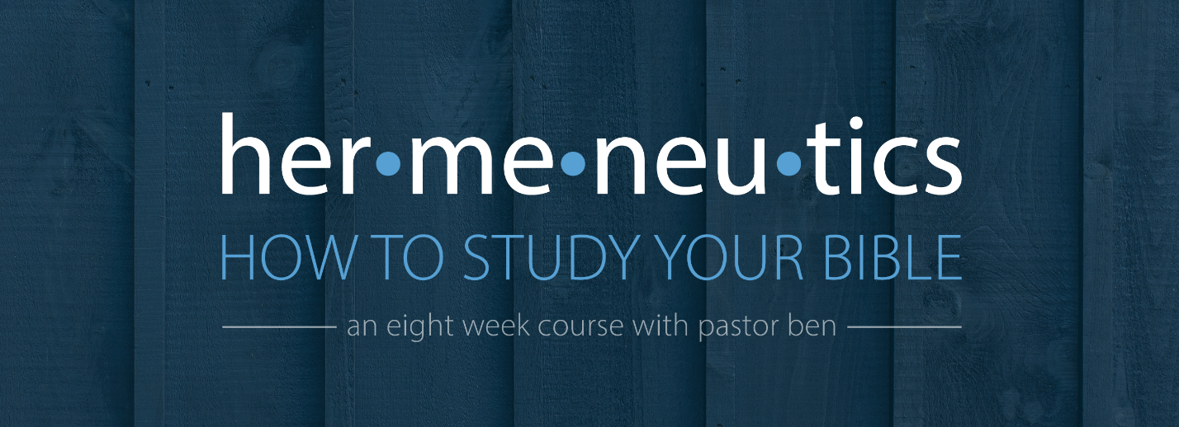
Lesson 8 – Studying the Prophets
Assignment

Read Hosea 11:1-11 several times: quickly, at a normal rate, and slowly.
Look at the context. What was going on in Hosea’s world? What is the meaning of the reference to Ephraim? ___________________________________________________________________
______________________________________________________________________________
______________________________________________________________________________
______________________________________________________________________________
______________________________________________________________________________
______________________________________________________________________________

Observe the passage carefully. Look for repeated words, themes, and ideas. Look for things that are confusing or merit deeper study. What figures of speech do you see? _______________
______________________________________________________________________________
______________________________________________________________________________
______________________________________________________________________________
______________________________________________________________________________
______________________________________________________________________________
Outline the passage.

Study key words. Where were Admah and Zeboim? Who is the “they” of verse 2? ____________
______________________________________________________________________________
______________________________________________________________________________
______________________________________________________________________________
______________________________________________________________________________
______________________________________________________________________________
______________________________________________________________________________

Study themes. Which of the three big themes of the prophets do we see in this passage?
______________________________________________________________________________
______________________________________________________________________________
______________________________________________________________________________
______________________________________________________________________________
______________________________________________________________________________
______________________________________________________________________________
______________________________________________________________________________

What does this passage teach us about God and man, and how should it change the way we think, desire, and behave? ________________________________________________________
______________________________________________________________________________
______________________________________________________________________________
______________________________________________________________________________
______________________________________________________________________________
______________________________________________________________________________
______________________________________________________________________________
______________________________________________________________________________

