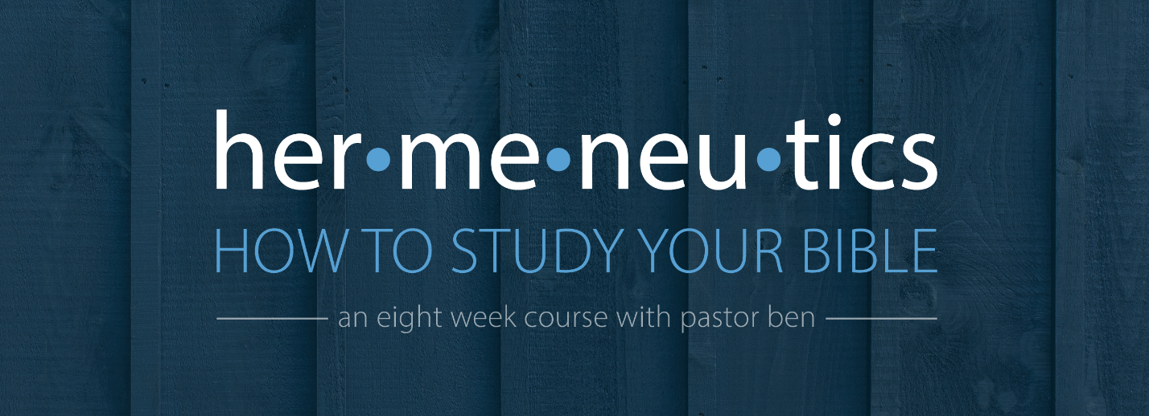
Lesson 7 – Studying Poetry and Wisdom
Assignment

For this assignment, we will take a single psalm and study it in greater depth.
Read Psalm 63 several times: quickly, at a normal rate, and slowly.
Look at the context. Where was David when he wrote the Psalm? _______________________
______________________________________________________________________________
______________________________________________________________________________
______________________________________________________________________________
______________________________________________________________________________
______________________________________________________________________________
Observe the passage carefully. Look for repeated words, themes, and ideas. Look for things that are confusing or merit deeper study. What figures of speech do you see? How does the parallelism in this passage work? __________________________________________________
______________________________________________________________________________
______________________________________________________________________________
______________________________________________________________________________
______________________________________________________________________________
______________________________________________________________________________
Outline the passage.

What is the idea behind the Hebrew word for meditate? What does David mean by “lower parts of the earth”?_____________________________________________________
______________________________________________________________________________
______________________________________________________________________________
______________________________________________________________________________
______________________________________________________________________________
______________________________________________________________________________
______________________________________________________________________________

Study a theme or two from this psalm. What is David talking about and what does he say about what he is talking about? ________________________________________________________
______________________________________________________________________________
______________________________________________________________________________
______________________________________________________________________________
______________________________________________________________________________
______________________________________________________________________________
______________________________________________________________________________
______________________________________________________________________________

What does this passage teach us about God and man, and how should it change the way we think, desire, and behave? ________________________________________________________
______________________________________________________________________________
______________________________________________________________________________
______________________________________________________________________________
______________________________________________________________________________
______________________________________________________________________________
______________________________________________________________________________
______________________________________________________________________________

