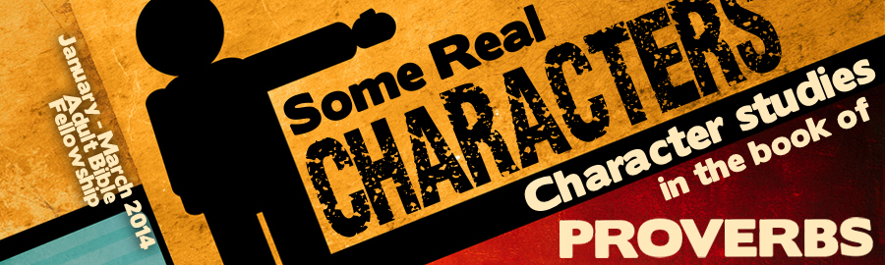
LESSON 6: “The Transgressor” Date:
KEY VERSE: Proverbs 11:3 – “The integrity of the upright shall guide them; but the perverseness of transgressors shall destroy them.”
INTRODUCTION
As with many of the “real characters” in the book of Proverbs, the “transgressor” is a difficult character to describe. The dictionary says a “transgression” is the “exceeding of the limits, or the breaking of a rule.” While this is true, the Hebrew idea of a “transgression” is much more colorful. There are four different Hebrew words that are translated “transgressor” or “transgression” in the book of Proverbs.
- To transgress is to act deceitfully or to be a hypocrite (Prov. 11:3) — The Hebrew word, baw-gad, means to act in a deceitful manner or to deal faithlessly. It describes an unfaithful man who does not honor an agreement.
- To break a law by cover-up (Prov. 16:10) — This verse contains the Hebrew word, maw-al, and has the idea of covering up something deceitfully in order to break a law.
- To pass over or to ignore (Prov. 26:10) — Literally, Proverbs 26:10 is saying, “God rewards those who pass unrighteously by a matter.” To see someone in need and to “pass by” is to commit a sin of omission.
- To rebel (Prov. 12:13) — This verse contains the Hebrew word, peh’-shah, which means to rebel. This word is found frequently in Proverbs (Prov. 12:13; 17:9, 19; 19:11; 28:2, 21, 24; 29:6, 16, 22).
THE TEMPTATIONS OF THE TRANSGRESSOR
There are specific temptations that pull at the heart of the transgressor.
- He loves a (Prov. 17:19; 29:22).
- He shows (Prov. 28:21).
- He is led by peer (Prov. 29:16).
- He is (Prov. 28:24).
- He is a companion of (Prov. 23:27-28).
THE DIFFICULTIES OF THE TRANSGRESSOR
Transgressors may choose their actions but they cannot choose their consequences.
- Transgressors will be (Prov. 11:6).
- Transgressors will be victims of (Prov. 13:2).
- Transgressors encounter many (Prov. 13:15).
- Transgressors are caught in their (Prov. 12:13).
- Transgressors are weak (Prov. 28:2).
- Transgressors oppose (Prov. 22:12).
THE FUTURE OF THE TRANSGRESSOR
Note the predications that Proverbs makes in regard to the future of the transgressor:
- He will be out of the earth (Prov. 2:22).
- He will be (Prov. 11:3).
- He will face (Prov. 26:10).
- He will , as the upright stand (Prov. 21:18).
HOW NOT TO TRANSGRESS
Proverbs tells us that this is a character to be avoided. Let’s learn how:
- Don’t be a (Prov. 17:9).
- Get away from (Prov. 19:11).
- Be ever aware of coming (Prov. 16:10).
CONCLUSION
The character of the Transgressor is large in Proverbs and sadly, it is large in the earth. God’s children ought to be ever so careful to live far apart from transgression.

