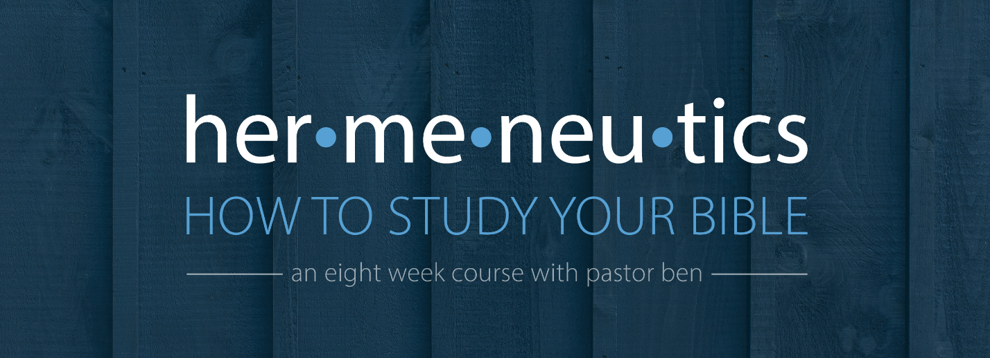
Lesson 6 – Studying Stories
Assignment

For this assignment, we will take a single story from Scripture and study it in greater depth.
Read the book of 1 Kings 19:1-18 several times: quickly, at a normal rate, and slowly.
Look at the context. What is the historical setting? What is the literary setting? ____________
______________________________________________________________________________
______________________________________________________________________________
______________________________________________________________________________
______________________________________________________________________________
______________________________________________________________________________
Observe the passage carefully. What 3 locations are mentioned in the story, and how do they relate? What can we learn about Elijah and the Lord from their behavior and actions? What specific details are we given that seem to be important, details that might otherwise be overlooked? ___________________________________________________________________
______________________________________________________________________________
______________________________________________________________________________
______________________________________________________________________________
______________________________________________________________________________
______________________________________________________________________________
Outline the passage.

What does the name Elijah mean, and how might that name contribute to the story of his life, and this chapter in particular?_____________________________________________________
______________________________________________________________________________
______________________________________________________________________________
______________________________________________________________________________
______________________________________________________________________________
______________________________________________________________________________
______________________________________________________________________________

Study the theme of this story. Do we have any other examples of this kind of interaction between God and a prophet in Scripture? How might these examples reinforce and explain one another? ______________________________________________________________________
______________________________________________________________________________
______________________________________________________________________________
______________________________________________________________________________
______________________________________________________________________________
______________________________________________________________________________
______________________________________________________________________________
______________________________________________________________________________

What does this passage teach us about God and man, and how should it change the way we think, desire, and behave? ________________________________________________________
______________________________________________________________________________
______________________________________________________________________________
______________________________________________________________________________
______________________________________________________________________________
______________________________________________________________________________
______________________________________________________________________________
______________________________________________________________________________

