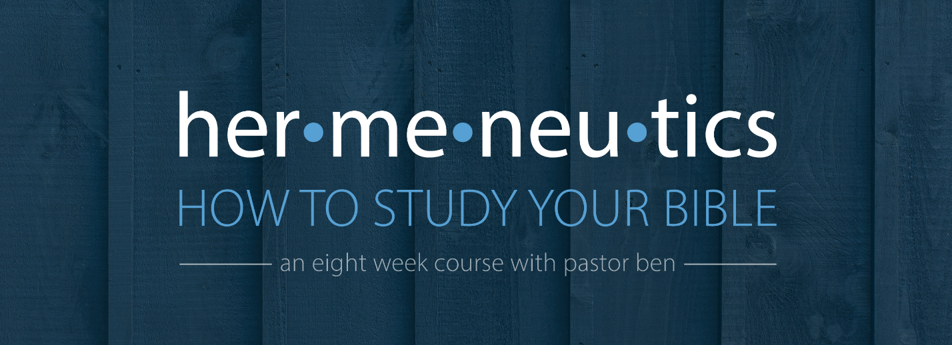
Lesson 5 – Studying Letters
Assignment

For this assignment, we will take a single passage of Scripture from the one of the letters and study it out in greater depth.
Read the book of Philippians in one sitting, then read Philippians 1:27-2:11 several times.

What is the context of the book of Philippians? Why is Paul writing the letter? _____________
______________________________________________________________________________
______________________________________________________________________________
______________________________________________________________________________
______________________________________________________________________________
______________________________________________________________________________
Observe the text carefully, noting repeated words, difficulties worth exploring later, cross-references and anything else that catches your attention or piques your curiosity. ___________
______________________________________________________________________________
______________________________________________________________________________
______________________________________________________________________________
______________________________________________________________________________
Outline the passage.

Study key words, focusing in on the words “robbery” (2:6) and “made himself of no reputation” (2:7). _________________________________________________________________________
______________________________________________________________________________
______________________________________________________________________________
______________________________________________________________________________
______________________________________________________________________________
______________________________________________________________________________
______________________________________________________________________________

Study the theme of this letter by asking “What does this passage talking” and “what does Paul have to say about what he teaches?” __________________________________________
______________________________________________________________________________
______________________________________________________________________________
______________________________________________________________________________
______________________________________________________________________________
______________________________________________________________________________
______________________________________________________________________________
______________________________________________________________________________

What does this passage teach us about God and man, and how should it change the way we think, desire, and behave? ________________________________________________________
______________________________________________________________________________
______________________________________________________________________________
______________________________________________________________________________
______________________________________________________________________________
______________________________________________________________________________
______________________________________________________________________________
______________________________________________________________________________

