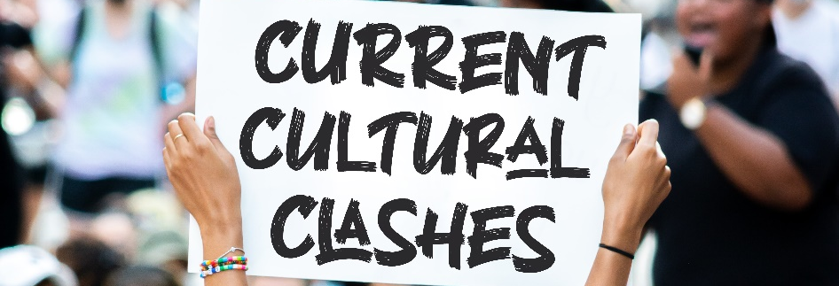
The Christian and Politics
Critical Race Theory (CRT) seems to be everywhere – in politics, in How should Christians think about their country and their God? In our politically polarized country, this question is more important than ever. What does the Bible have to say?
The Accusations
The Secular Accusation: Christians are illegitimately bringing their ideas into the public sphere and that’s bad for America.
The Christian Accusation: Christians are following after the idol of love of country and that’s bad for the church.
The Biblical Principles
- God cares about individuals, but God also cares about nations.
- God cares about nations in the OT (Amos 1:1-2:3)
- God cares about nations in the millennium (Zechariah 14:16ff)
- God cares about nations in heaven (Rev 5:9)

- Governments are ground zero for spiritual warfare.
- We see this in the OT (Daniel 10:10-14; 20-21).
- We see this in the NT (Ephesians 6:10-12).

- We should fight for righteousness in the public square (Proverbs 14:34, Matthew 5:6).
- We should show grace and humility to people with whom we disagree.
- We should submit to government (Romans 13:1-7; 1 Peter 2:13-17).
  - Because doing so is obedience.
  - Because doing so is for our good.
  - Because doing so impacts our testimony.
- We should be gracious with unbelievers (Colossians 4:5-6).

Application – Finding the Balance
“When first things are put first, second things are not suppressed but increased.” – C.S. Lewis
- My primary allegiance must be to God’s kingdom (Matthew 6:33).
- My primary mission must be to spread the gospel (Romans 1:16-17).
- My primary community must be the church of God (Colossians 3:11).
Application – Satan’s Goals and Fears
Satan’s Goals
- Satan wants to divide Christians.
- Satan wants Christians to love America more than God.
- Satan wants Christians to ignore America.
Satan’s Fears
- Christians who graciously and confidently stand for righteousness.
- Christians who pray for their country and leaders.
- Christians who

