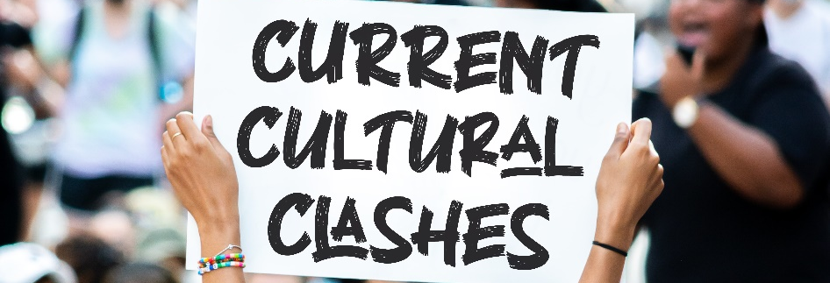
The Christian and Critical Race Theory
Critical Race Theory (CRT) seems to be everywhere – in politics, in education, even in conversations with neighbors and family. Some treat it like it’s the devil; others seem to think that only CRT will be enough to undo our long history with racism. But what is CRT? And how should Christians respond to it biblically?
What is Critical Race Theory?
Why is CRT so hard to define?
- CRT is a very technical worldview.
- CRT has become divisive and unpopular.
- CRT is a broad movement.
The Academic Meaning
- Critical Theory (CT) sees people as groups, not individuals.
- CT sees groups as either oppressed or oppressors.
- CT believes power is exerted by the oppressor throughout all facets of the culture – hegemony.
- CT argues that only the oppressed know what it means to be oppressed.
- CT seeks to liberate the oppressed by giving them power.
- CRT sees racism as prejudice plus power.
- CRT sees racism as built into the very institutions of America.
- CRT believes that unjust systems must be pulled down – deconstruction.
The Popular Meaning
- A concern to educate on the history of racism.
- A concern over the lingering effects of hundreds of years of racism.
- A concern over ongoing racism.
The Threefold Christian Response
Some embrace CRT (Rasool Berry; Jemar Tisby). “There’s a lot we can learn from CRT!”
Some look to affirm what they can, and critique what they must (David French, Al Mohler). “There are some helpful observations in CRT, and when we push back we need to do so carefully and not reflexively.”
Some denounce CRT as dangerous (Neil Shenvi, Voddie Baucham). “CRT might get a few things right, but our overall posture needs to be to warn about its dangers.”

The Biblical Perspective
- We must beware the dangerous, empty, and deceptive philosophies of the world (Colossians 2:8).
- We must hold to the sufficiency of Scripture (2 Peter 1:3).
- We should as Christians listen to and empathize with those who have or are hurting (Romans 12:15; Proverbs 18:13).
- We must be sensitive to the injustice in America’s past and present (Isaiah 1:12-18).
- Children are not to pay for the sins of their parents (Ezekiel 18:20).
- As Christians our primary identity is in Jesus Christ (Galatians 3:27-28).
- Racial tension can ultimately be resolved only through the gospel (Ephesians 2:11-22).

