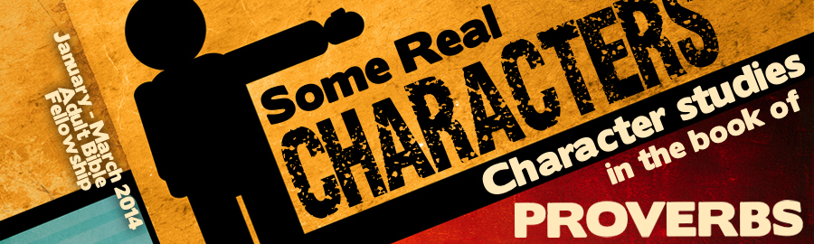
LESSON 2: “Proud of It!” Date:
KEY VERSE: Proverbs 11:2 – “When pride cometh, then cometh shame: but with the lowly is wisdom.”
INTRODUCTION
One of the most striking contrasts featured in the book of Proverbs is the contrast between the proud and the humble. It was when Lucifer’s heart was lifted up in pride that he fell (Is. 14:12-17). Satan appealed to pride when he tempted Eve in the Garden of Eden (Gen. 3:5). Pride is a root cause of many sins (I John 2:16). God promises to resist the proud and give grace to the humble (I Pet. 5:5).
THE PITFALL OF PRIDE
Before we can clearly discuss the topic of pride, it is necessary for us to formulate a working description of this dreadful character trait. Proverbs paints an unforgettable picture of pride by using _______ different Hebrew words in order to display three prominent characteristics of the proud. English words like, “pride,” “arrogance,” and “haughtiness” are found in every translation of the book of Proverbs. Behind these words are some powerful pictures.
- A proud person has an estimation of his worth.
The Hebrew word, rawkhawb, is found in Proverbs 21:4 and 28:5. It pictures something large or broad (Ex. 3:8; Neh. 3:8). An over-inflated estimate of oneself is typical of those who are proud.
- A proud person has an estimation of his worth.
The Hebrew word, gayeh, is frequently used in Proverbs to speak of the proud (Prov. 8:13; 14:3; 15:25; 16:5, 17, 18, 19; 21:24).
- A proud person has a spirit.
The Hebrew word, zawdone, pictures the idea of “boiling.” This word is used in Proverbs 11:2; 13:10 and 21:24 to speak of the rebellious, insolent, presumption of the proud.
THE REPRESENTATIONS OF PRIDE
Proverbs tells us that pride is communicated through three primary body parts:
- The (Prov. 6:16-17)
- The (Prov. 14:3; 21:23-24)
- The (Prov. 18:12)
THE RESULTS OF PRIDE
God promises a painful end to those who are proud.
- The proud will make decisions (Prov. 21:24).
- The proud will live a life full of (Prov. 13:10; 28:25).
- The proud will find (Prov. 11:2).
- The proud will (Prov. 15:25; 16:18; 29:23).
THE HONOR OF HUMILITY
Though many different Hebrew words are used to picture the humble and lowly in the book of Proverbs, two primary pictures emerge.
- Some are made humble because of (Prov. 11:2; 15:33; 18:12 and 22:4).
- Some become humble by personal (Prov. 3:34; 6:3; 16:19 and 29:23).
- Instructions are given to those who would be humble.
a. You must be (Prov. 6:3).
b. You must choose the right (Prov. 16:19).
- Gifts are promised for those who would be humble.
a. (Prov. 3:34)
b. (Prov. 29:23)
c. (Prov. 11:2)

