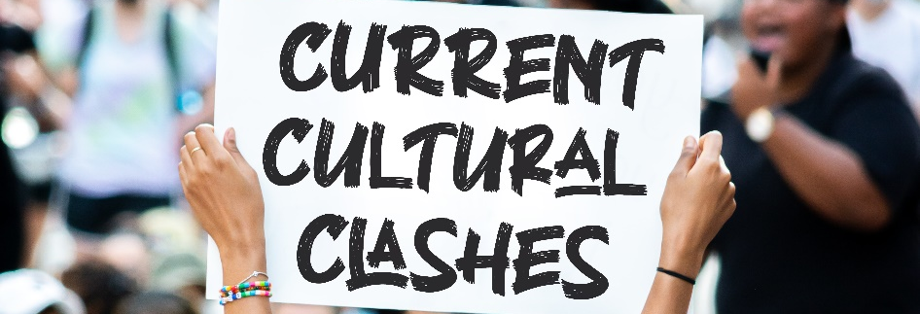
The Christian and the LGBTQ Movement
The issue of homosexuality is one that has taken the nation by storm. 50 years ago the idea of gay marriage was unthinkable, now anyone who rejects it is in danger of being “canceled.” How should we as believers think and live in this confusing world?
Fighting a Four-Front War
- Exegetical Front: Defend the Scriptural position.
- Apologetic Front: Respond to the corrupt culture.
- Discipline Front: Confront Christians who have caved.
- Discipleship Front: Help believers who are struggling.
Exegetical Front: Defending the Bible
Genesis 19 – Sodom and Gomorrah: While the sin of Sodom and Gomorrah was more than just homosexuality, homosexuality undoubtedly played a major role.
Leviticus 18 and 20 – Old Testament Prohibitions: The Old Testament prohibitions were in affect for 1,500 years, and if they are repeated in the New Testament they remain binding.
1 Corinthians 6 and 1 Timothy 1 – “Homosexuals”: Paul coins a new word here that is based on the prohibitions of Leviticus.
Romans 1 – Homosexuality Is “Against Nature”: Even gay-affirming scholars admit that Paul here is categorically rejecting all same-sex behavior as wrong
Matthew 19 and Genesis 2 – Christ, Divorce, and Creation: When faced with an issue not directly mentioned in the Genesis account, Jesus points back to Creation as the pattern for all such questions.
Apologetic Front: Responding to the Culture
- We must respond to our culture with courage (Daniel 1:8)
- We must respond to our culture with compassion (Col 4:6)
- We must respond to our culture with wisdom (Daniel 1)
- We must respond to our culture with the gospel (Rom 1:16-17)
Discipline Front: Confronting Sinning Believers
- Bad influences will corrupt you and those around you (1 Cor 15:33)
- Bad influences are more corrupting coming from a believer (1 Cor 5:9ff).
- Those who sin should be confronted in kindness with the goal of restoration (Gal 6:1).
- Those who continually, openly rebel against God should be removed from the church, and believers should not associate with them (1 Cor 5:9ff).
- We may associate with unbelievers living in rebellion against God, but not with believers living in rebellion against God.
Discipleship Front: Helping Struggling Believers
- We need to confront worldly thinking (Romans 12:1-2).
  - Worldly thinking about gay identity (1 Cor 6:9-11)
  - Wrong thinking about existentialism (cf Gen 3:1ff)
- We need to emphasize the self-denial of discipleship (Matt 16:24-26).
- We need to balance shame and compassion (Eph 5:11-12; Rom 1:26-28; Gal 6:1).

