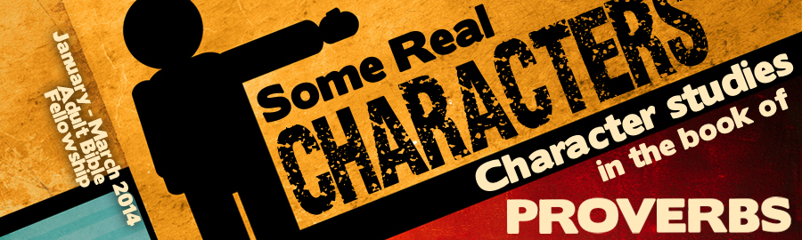
LESSON 1: “A Man of His Word” Date:
KEY VERSE: Proverbs 18:21 – “Death and life are in the power of the tongue.”
INTRODUCTION
Proverbs has much to say about the use of the tongue, for the tongue is a study in contrasts (James 3:9). The tongue can both bless and destroy. The tongue can do good and evil. The tongue is an enormously powerful tool. “Death and life are in the power of the tongue, and they that love it shall eat the fruit thereof” (Prov. 18:21). Those who love to speak will eat what they say—for good or for evil
In order to walk in wisdom, we must learn to guard our words! Whether for good or for evil, you will be known by your words. Let’s investigate the teachings of Proverbs regarding the danger and blessing of words as we attempt to identify what God calls, “good words.”
THE DANGER OF OUR WORDS
James has a great deal to say about our words. In James 3, our words are compared with ______________ (James 3:6). Fire is a necessary element but without proper control it can be one of the most destructive forces known to man. In the same way, our words can pose great danger.
- Words have the power to (Prov. 26:24-26).
- Words have the power to (Prov. 5:3-4; 7:5, 21).
- Words have the power to (Prov. 6:2).
- Words have the power to (Prov. 11:9).
One day an account will be given of every word ever spoken (Matt. 12:26). In truth, we are not known by our smile, our eyes, or our accomplishments—we are known by our words! Be careful what you say.
THE BLESSING OF OUR WORDS
Because words are powerful tools for good and evil, God wants us to use our words to bring blessings to others.
- Words can be a source of (Prov. 10:11; 10:21).
- Words can be a source of (Prov. 12:18; 16:24).
- Words can be a source of (Prov. 10:13; 15:7; 20:15).
Countless words must be carefully considered in order for a virtuous life to be constructed. Is your mouth a fountain of wisdom? Whose life will be made better because of your words?
THE IDENTIFICATION OF OUR WORDS
We are not left to guess how God wants us to speak. Before we speak, we must be students of what God would have us to say. The book of Proverbs characterizes good words in the following ways.
WHAT GOOD WORDS ARE —
- Good words are (Prov. 24-25-28; 28:23).
- Good words are (Prov. 17:27). There are three good reasons for this:
- In order to be sure that you have the facts (Prov. 18:13)
- In order to turn away wrath (Prov. 15:1)
- In order preserve real power (Prov. 25:15)
- Good words are with care before they are put into the air (Prov. 15:28).
- Good words are (Prov. 10:32; 15:23; 25:11).
WHAT GOOD WORDS ARE NOT —
- Good words are not a substitute for (Prov. 14:23).
- Good words are not filled with (Prov. 27:2; 30:32).
- Good words are not (Prov. 29:19).
Prov. 18:21 — “Death and life are in the power of the tongue: and they that love it shall eat the fruit thereof.”

