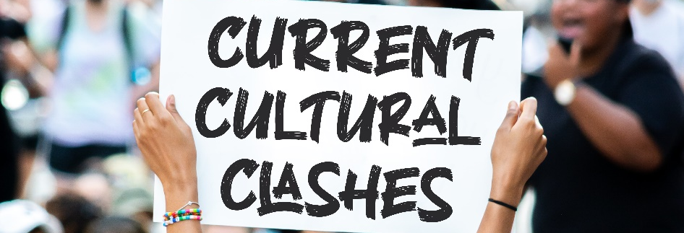
How To Apply the Bible
When the Bible Doesn’t Seem to Apply
Living life in the 21st century by using a book written between 1400 B.C. and 90 A.D. presents challenges to say the least. The Bible was written for all people of all time, but how do we take instructions written to ancient people and live our modern lives by them?
Two Difficulties with Studying the Bible
- The Bible “might not apply” because the ancient situation is a situation we no longer face – like instructions about idol food.
- The Bible “might not apply” because the current situation is not found in the Bible – like our responsibility in a democratic republic.
Living by God’s Word Today Requires Two Things
- Understanding – We need to know God’s Word and we need to know our culture.
- Wisdom – We need the ability to apply our knowledge of God’s Word to the contemporary issue.
When Dealing with Ancient Situations – Idol Food at Corinth
We will start by beginning with an ancient situation and drawing modern comparisons. This is what we do when we read our Bible regularly – trying to see what general principles can apply to my current situation. As we get better at this process, it will help us when we start with modern problems and go looking for biblical help.
Understanding – Knowledge
Historical Background – Idol temples and food offered to idols were a regular part of life, but Jews and the early church condemned eating food sacrificed to an idol.

Biblical Background – The Jerusalem council prohibited Gentiles from eating food sacrificed to idols (Acts 15:28-29). Jesus associates eating idol food with false teachers (Rev 2:14, 20). Paul would likely have told the Corinthians this during his 18-month stay in the city (Acts 18:11).

Paul’s Instructions – Paul warned the Corinthians that their behavior was unloving to other Christians (1 Cor 8-9), and that that their behavior was disloyal to God and spiritually disastrous (1 Cor 10).

Wisdom – Application
- Beware using theological rationalizations to justify sin.
- Another person’s spiritual good matters more than your rights.
- Take seriously the reality of supernatural evil.
When Dealing with Modern Situations – Civic Duty
When we study how to apply the Bible to modern situations, we are dealing with questions of wisdom and discernment. The goal is to discover what Christ would
Understanding – Knowledge
- Scripture tells us to honor authority (1 Pet 2:11-17; Rom 13:1-7).
- Paul used his citizenship to advance the gospel (Acts 16:35-40).
- Christians should seek to see righteousness followed (Prov 14:34).
- Christians should and be meek (Matthew 5:1-12; Col 4:5-6).
Wisdom – Application
- Disagree with politicians, but don’t mock them.
- Believers can and should use the law to advance the gospel.
- Believers must both stand for truth and be meek.

