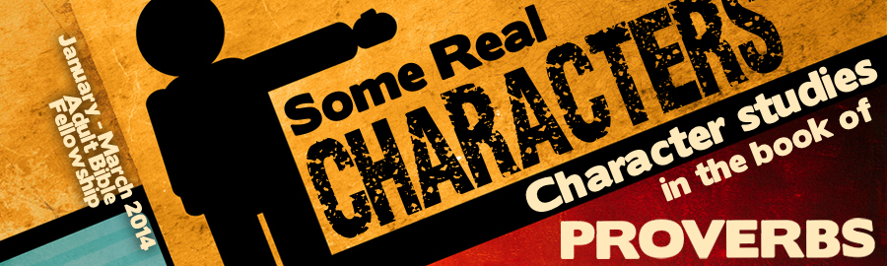
LESSON 10: “The Froward vs. The Righteous” Date:
KEY VERSE: Proverbs 3:32 – “For the froward is abomination to the Lord: but his secret is with the righteous.”
INTRODUCTION
Instruction is often best retained when comparisons are offered. The Proverbs often teach by comparison. Typically, comparisons are made evident through the use of the phrase, “But the.” The phrase, “But the,” is found times in Proverbs in order to highlight comparisons that God believes to be important. More than anything else, the book of Proverbs is filled with character comparisons. One of the most striking comparisons in the book of Proverbs is between the froward and the righteous.
Not only are there five direct comparisons between the froward and the righteous in Proverbs, the character of the forward is exposed times and the character of the righteous is examined in at least verses. God wants us to be very familiar with the difference between frowardness and righteousness.
THE FROWARD
There are four Hebrew words behind the word translated, “froward,” in our King James Bibles. The words translated “froward,” speak of crookedness, perversity, deceit and perversion. Thus, a froward person is a crooked or deceitful person.
- The froward plan things (Prov. 16:29-30).
- The froward perverse words (Prov. 4:24).
- The froward relationships (Prov. 16:28).
- The froward experience God’s (Prov. 10:31).
THE RIGHTEOUS
The righteous are spoken of more than any other character in the book of Proverbs. As opposed to the froward, the righteous are described by two important Hebrew words. Proverbs pictures the righteous walking straight lines and living in compliance with the law.
- The righteous know the of God (Prov. 3:32).
- Psalm 25:14 — The secret of the LORD is with them that fear him; and he will shew them his covenant.
- Proverbs 15:22 — Without counsel purposes are disappointed: but in the multitude of counsellors they are established.
- Jeremiah 23:18 — For who hath stood in the counsel of the LORD, and hath perceived and heard his word? Who hath marked his word, and heard it?
- Amos 3:7 — Surely the Lord GOD will do nothing, but he revealeth his secret unto his servants the prophets.
It appears that the “secret” of God refers to the “counsel” or “revelation” of God. How wonderfully true! God has provided His people with revelation sufficient for life and godliness (II Pet. 1:3).
- The righteous honestly (Prov. 13:5; 10:32).
One of the chief characteristics of the righteous as contrasted with the froward, the righteous are people of truth. Where there is no honesty, there is no holiness. Where there is no holiness, there is no real salvation.
- The righteous securely (Prov. 10:30).
While the froward stand to experience the awful judgment of God, the righteous will stand (Prov. 11:28; 12:3, 7). God promises that the righteous will stand so that they may confidently serve Him!
- The righteous walk in paths (Prov. 2:20).
Generations have walked the pathway of the righteous and though the path is narrow, it is discernible. Deuteronomy 17:20 challenges the righteous not to turn to the right hand or to the left but keep a straight path. Such a path is predictable because it conforms to the principles laid out in God’s word. On the path of righteousness, God promises to keep our steps from slipping (Ps. 91:12). God’s word is filled with wonderful promises for the righteous. The book of Proverbs 12:7 says, “The house of the righteous shall stand.”
CONCLUSION
We live in a generation in which the Lord’s sheep tend to like to wear wolves clothing. It is often difficult to discern any difference between professing believers and unbelievers. Those who avoid frowardness while seeking righteousness will stand out as remarkably different and will obtain favor with God!

