PRE-LESSON: “The Background of Galatians”
TEXT: Galatians Overview
INTRODUCTION
Merrill C. Tenney writes of Galatians:
Christianity might have been just one more Jewish sect, and the thought of the Western world might have been entirely pagan had it never been written. Galatians embodies the germinal teaching on Christian freedom which separated Christianity from Judaism, and which launched it upon a career of missionary conquest. It was the cornerstone of the Protestant Reformation, because its teaching of salvation by grace alone became the dominant theme of the preaching of the Reformers.
Indeed, Martin Luther, the great reformer who emerged from the clutches of Christ-plus-works Roman Catholicism, said, “The epistle to the Galatians is my epistle. To it I am, as it were, in wedlock. Galatians is my Katherine [the name of his wife].”
With such a foundational epistle before us, let’s begin our study through this book by considering some of the unique features of its background. Paul’s close ministry relationship with these churches is both fascinating to learn and instructive as a model.
PAUL’S RELATIONSHIP WITH THE GALATIAN CHURCHES
Paul had founded these Galatian churches (1:8-9; 4:19) at a time when he was physically suffering (4:13; probably from persecution—cf. Acts 13-14), but the new believers had welcomed him (4:14). Subsequently, he had labored for these churches (4:11).
He had apparently visited these churches more than once before writing this letter (4:13). We don’t know that Paul visited the Northern Galatian (ethnic area) region twice; but we do know that Paul visited the Southern Galatian (Roman province) region at least four times—twice on the First Missionary Journey, once on the Second Missionary Journey, and once on his Third Missionary Journey. Therefore, it seems best to understand these “churches of Galatia” (1:2) and these “Galatians” (3:1) as those in South Galatia among whom Paul enjoyed ministry in Acts 13:14-14:23; 15:36-16:6; 18:23. Other support for the South Galatian destination is as follows:
- Galatians deals with the problem of Judaizers who had penetrated the local churches. These Judaizers had already caused trouble for Paul in South Galatia on his First Missionary Journey, and the major highway that ran through South Galatia would have made those churches more accessible to them.
- Paul references Barnabas a couple times throughout his epistle, suggesting that the Galatian believers were familiar with him (cf. 2:13); Barnabas had only accompanied Paul in South Galatia and was not present on Paul’s expedition northward on his Second Missionary Journey (cf. Acts 15:36-16:8).
- A South Galatian concentration best fits Paul’s method of targeting main roads in the Roman provinces in order to strategically connect with large population bases.
- While Galatian churches helped in the collection (1 Corinthians 16:1), only representatives from South Galatia are mentioned (Acts 20:4).
The church seems to have been predominantly founded out of gentile paganism (2:5, 8; 4:8; 5:2; 6:12), but Paul’s assumption of his reader’s knowledge and grasp of the Jewish religion throughout chapters 2 through 4 also suggests a Jewish population. This theory fits with the demography of South Galatia according to Paul’s discovery of it on his First Missionary Journey, when he was accepted by the Gentiles and rejected by Jews.
While Paul’s tone is strong and striking in this letter, he clearly wishes he could handle this problem in a different manner—face-to-face with them, so that his love for them would be evident (4:19-20).
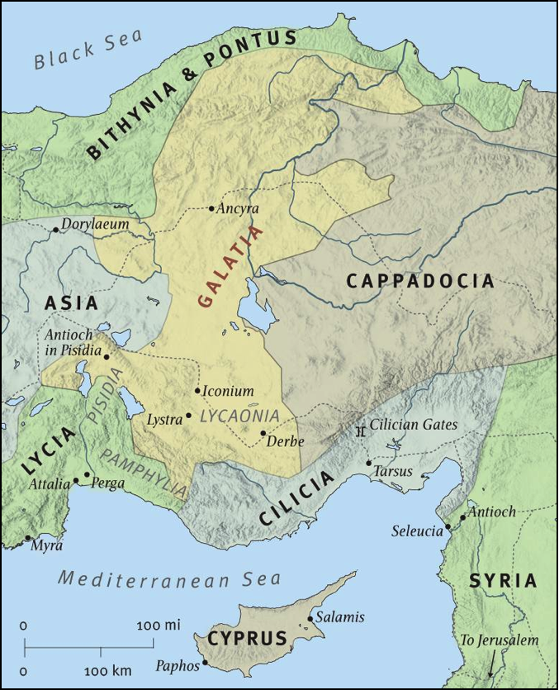
The Region of Galatia
PAUL’S TIMELINE OF GALATIAN MINISTRY
- First Missionary Journey • ~AD 46-47 (Acts 13:14-14:23)
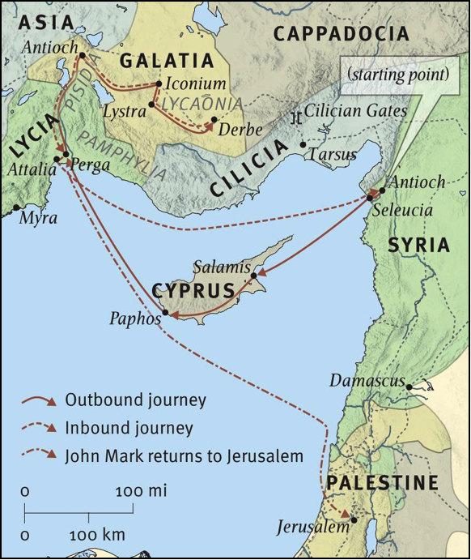The first Galatian town Paul and Barnabas visited was Pisidian Antioch (Acts 13:14-51), where two clear Sabbath day gospel-messages brought forth fruit among the Gentiles but provoked persecution from the Jews. Paul then went to Iconium (Acts 13:51-14:6), and experienced almost the same response—fruit among the Gentiles (ad some Jews this time), but persecution from the unbelieving Jews. Fleeing Iconium, Paul next began to minister at Lystra (Acts 14:6-20), where he was mistaken as a god by the pagans and once again persecuted (this time stoned and left for dead) by Jews from Antioch and Iconium. God revived Paul, and he departed Lystra the next day and went to Derbe (Acts 14:20-21), where he apparently enjoyed his freest and most fruitful ministry. Finally, according to Acts 14:21-23, Paul’s missionary team “returned to Lystra and to Iconium and to Antioch, strengthening the souls of the disciples, encouraging them to continue in the faith, and saying that through many tribulations we must enter the kingdom of God. And when they had appointed elders for them in every church, with prayer and fasting they committed them to the Lord in whom they had believed.” So, Paul visited each city two times, evangelizing, discipling, and structuring the local churches.
Paul’s First Missionary Journey
- Writing of the Epistle to the Galatians • ~AD 48 (Acts 14:26-28)
Paul returns to his sending church at Antioch (in Syria; different from Pisidian Antioch) and gives a report on his first missionary journey. During his subsequent stay at Antioch (v. 28), he writes this epistle to the churches he had just visited. This harmonizes with the following details:
- The Antioch church is particularly excited about how “God had opened a door of faith to the Gentiles” (v. 27), which is whose Paul’s missionary ministry had been directed at and who he is primarily addressing in Galatians (cf. 2:5, 8; 4:8; 5:2; 6:12).
- Only a brief span of time would have elapsed since his initial founding of those churches, which would explain why he is so saddened and surprised that the believers had “so quickly” deserted the true gospel (Galatians 1:6).
- If we translate Galatians 4:13 with “at the first” or “the first time,” we can understand it to refer to the first of his two visits to these churches on his First Missionary Journey (cf. Acts 13:14-14:21a).
- The suffering and welcoming that Paul refers to in Galatians 4:13-14 can be understood as the cycle of persecution and fruit that Paul met in each Galatian city.
- Jerusalem Council • ~AD 48/49 (Acts 15:1-35)
Paul’s visit to Jerusalem recorded in Galatians 2:1-10 was not at the Jerusalem Council, but instead during the famine of Acts 11:27-30 sometime during AD 44-47 (also, 12:24-25). While not all agree with this interpretation, it seems to best fit the chronology and information provided in Galatians 2 and Acts 11. Consider the following support:
- The same two churches were involved—Antioch and Jerusalem—and the same two delegates—Paul and Barnabas (Note: This is also true of the Jerusalem Council in Acts 15. Albeit, Acts 15:2 suggests there were other delegates with Paul and Barnabas, while Galatians 2:1 identifies Titus as merely a companion that Paul took along with him.)
- It is pretty clear in Galatians 2 that Paul is describing his second post-conversion trip to Jerusalem, which, according to Acts, was during the famine of Acts 11:27-30. The first visit is recorded in Acts 9:22-30, when Paul fled from Damascus to Jerusalem, where he visited with the apostles, and then departed to Tarsus (capital of Cilicia). This fits with the record of Paul’s first visit to Jerusalem in Galatians 1:15-21—he went to Jerusalem from Damascus, visited with Peter and James (the Lord’s brother), and then left for Syria and Cilicia.
- Paul states that on his second visit he “went up because of a revelation,” which can be understood as a reference to Agabus’ prophesy in Acts 11:28.
- Unlike the Acts 15 visit, Galatians 2 gives no suggestion as to a question being brought before the church, or an authoritative answer being given. In fact, the “only” exhortation was that Paul “remember the poor” (Galatians 2:10), which is exactly why Paul was in Jerusalem on the Acts 11 visit (cf. v. 29).
- Paul’s private discussion with the apostles in Jerusalem (Galatians 2:2) better fits the anonymity of the Acts 11 visit than the public church conference of Acts 15 (cf. vv. 4, 6, 12)—Paul’s private demeanor makes sense if his public apostolic mission wasn’t confirmed until Acts 13:2. Furthermore, Peter’s hypocrisy in Galatians 2:11-14 is more sensibly understood if it precedes the council of Acts 15, especially in light of his leadership at that event and his support of Paul (cf. vv. 6-12). So, his interactions with Peter would have been: first, when he visited Jerusalem during the famine (Acts 11:29-30; Galatians 1:18-21); second, when Peter came to Antioch (either before Paul’s First Missionary Journey or, more likely, afterwards during his extended furlough there) and Paul rebuked him (Galatians 2:11-14); and third, when they both attended and spoke at the Jerusalem Council (Acts 15:1-35).
- Since this letter to the Galatian churches is dealing with the same issues as the Jerusalem Council, it would have been incredibly germane for him to have referenced the official decision of Acts 15:23-29, like he did on his Second Missionary Journey (cf. Acts 16:4). The absence of any such reference suggests that the council had not yet convened. This is an argument from silence, but it is (in my opinion) “deafening silence.”
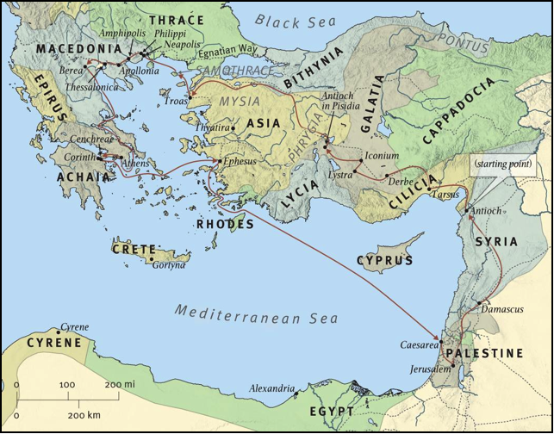Interesting Side Note: According to Galatians 1:18-19, Paul stayed with Peter for fifteen days during his famine visit in Jerusalem, and he also met with James, the brother of Jesus. Acts 12:1-5 records that sometime after that fifteen-day period, before Paul left Jerusalem (cf. Acts 12:25), Herod the king martyred James (Jesus’ disciple and the brother of John and son of Zebedee) and imprisoned Peter. When Paul finally left Rome, he took with him John Mark (Acts 12:25), in whose home the church had gathered to pray for Peter’s release (Act 12:12), which came in miraculous fashion (Acts 12:6-17). Undoubtedly, Paul had gathered with the church during that prayer vigil, and had perhaps even been lodging there. This would explain how Paul met John Mark and developed a friendship with him. And, it was at this prayer-turned-praise service that Paul learned some important lessons that would buttress his faith during a similar experience that he would soon face (Acts 16:19-34). On the one hand, Paul was not yet the powerful apostle; instead, he was in the shadow of others—watching, learning, and growing. Even Paul needed this ministry preparation and training. On the other hand, he didn’t wait until he “felt” ready or was “officially” commissioned (which happens in Acts 13) before he started pouring himself into others and building ministry partnerships.
Paul’s Second Missionary Journey
- 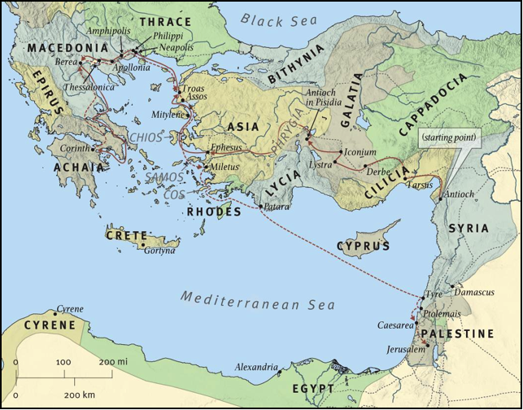Second Missionary Journey • ~AD 48/49-51 (Acts 15:26-16:6)
Paul’s Third Missionary Journey
Paul again followed the major land route that passed through Galatia, from Tarsus to Derbe to Lystra to Iconium to Pisidian Antioch. Note that while the Holy Spirit initiated the First Missionary Journey (Acts 13:2), it was Paul’s own discipleship burden that provoked the second. His reason for this second missions endeavor was first and foremost to “return and visit the brothers in every city where [they] proclaimed the Word of the Lord [to] and see how they [were]” (Acts 15:36; 16:5); they also delivered the decrees of the Jerusalem Council (Acts 16:4). From this purpose, we learn that the great evangelistic apostle understood the vital importance of discipleship for all those who responded to his preaching in saving faith. Clearly, his apostolic mission was more than our strict definition of evangelism; it involved the discipleship of souls and the planting of growing and strengthened churches. Paul’s example of active concern for the growth and stability of his converts is an important model for us (cf. Galatians 4:11; Colossians 1:24-2:5).
- Third Missionary Journey • ~AD 52-57 (Acts 18:22-23ff)
Paul once again visited the churches in Galatia to strengthen them.
PAUL’S REASON FOR WRITING THE EPISTLE TO THE GALATIANS
The key passage in this epistle that forms its theme is Galatians 1:6-9.
I am astonished that you are so quickly deserting Him who called you in the grace of Christ and are turning to a different gospel—not that there is another one, but there are some who trouble you and want to distort the gospel of Christ. But even if we or an angel from heaven should preach to you a gospel contrary to the one we preached to you, let him be accursed. As we have said before, so now I say again: If anyone is preaching to you a gospel contrary to the one you received, let him be accursed.
False teachers, probably claiming the name Christian, had crept into the churches and were preaching what they called the “gospel.” However, it was different from what Paul had preached, for it taught that obedience to the Mosaic Law, in addition to faith in Christ, was necessary for salvation and a righteous standing before God (2:3-5, 11-14; 3:3-5; 4:8-11, 21-31; 5:1-4; 6:12-15). Keller summarizes their doctrine this way, “[These] teachers…told these young Christians that their performance mattered. Of course they needed to trust Christ and His death; and then, if they wanted truly to be acceptable to God, they needed to get circumcised and get on with keeping God’s laws. Their efforts were what mattered.” He further explains the implications of this: “By insisting on Christ-plus-anything-else as a requirement for full acceptance by God, these teachers were presenting a whole different way of relating to God (a ‘different gospel,’ 1:6) from the one Paul had given them (‘the one we preached,’ 1:8).” These Judaizers were furthermore undermining Paul’s apostolic authority in order to strengthen their own position.
Kent argues convincingly that problems concerning “the relation of Gentile converts to the Mosaic Law” were a natural issue in light of the Jewishness of the first converts. However, these false teachers had refused to be instructed in this area and were corrupting truth with deception, and Paul’s evaluation of their “different way of relating to God” is clear: “[Their] heresies [were] so series that Paul denies to their doctrine the name gospel (1:7).” Furthermore, Paul makes it clear that they “acted out of false motives: that is, out of personal ambition (cf. 4:17; 6:13) and out of offense at the cross of Christ (6:12).” Finally, Paul tells us in Romans 3:20 that the false gospel of Christ plus works leads to condemnation, not salvation.
Paul’s burden in this letter, then, is to demonstrate theologically and practically that “their spiritual problem is not only caused by failing to live in obedience to God, but also by relying on obedience to Him.” Nothing has changed. “The choice between the gospel of Christ-alone and the false gospel of Christ-plus is still one which Christians face today. Christ-plus may not look the same in our cultures as it did in Galatia. But it’s still an attractive message, a flattering view, and a subtle reversal of the true gospel…and so it’s still deadly.” “The contemporary relevance of Galatians,” writes Vos, “is that it attacks the ever present desire of men to achieve salvation by their own efforts and the tendency of Christians to live the Christian life in their own strength or in a legalistic way.”
Paul’s Epistle to the Galatians serves as “the definitive statement on the problem of legalism” and a comprehensive treatise on real freedom in Christ.
PAUL’S OUTLINE IN THE EPISTLE TO THE GALATIANS
- The Priority of the Gospel (Summary) — 1:1-2:10
- The Protection of the Gospel (Salvation) — 2:11-4:31
- The Privileges of the Gospel (Sanctification) — 5:1-6:18
OUR REASON IN STUDYING THE BACKGROUND OF GALATIANS
- Enjoyment
Some enjoy it! And, it is fascinating to correlate passages and draw reasonable and revealing conclusions.
- Exegesis
Unlike some of the other local churches written to by Paul, the churches of Galatia are so clearly recorded in Acts that our understanding of their history with Paul will enhance our understanding of the epistle.
- Example
By tracing Paul’s ministry with these churches in Acts, we have discovered afresh his pastoral concern for people. He loved people deeply and was devoted to their spiritual protection, even from hundreds of miles away and even when he had just left them. His ministry priorities are exemplary—discipling people and defending truth.
- Encouragement
Seeing the connections between the New Testament epistles and the church’s history book of Acts serves to reaffirm the harmony and authenticity of Scripture.
FOOTNOTES

Merrill C. Tenney, Galatians (Grand Rapids: Eerdmans, 1957), p. 15.
“The first” (i.e., “the first time”) suggests that he had visited them at least twice and he is referring to the very first visit. The translation “formerly,” while plausible, seems superfluous if he had only visited the church one time (i.e., at its founding).
In fact, Acts isn’t even clear that he visited it at all, and it certainly doesn’t indicate that he founded any churches there.
Macarthur simplifies the argument: “The fact that the book of Acts mentions the four churches established by Paul in south Galatia and mentions none in the rest of the province makes it probable that the epistle was addressed primarily to those southern churches” (John F. MacArthur Jr., Galatians in the MacArthur New Testament Commentary [Chicago: Moody Press, 1983], Introduction).
“The mention of Paul’s being ‘brought to the apostles’ (9:27) must refer only to Peter and James the Lord’s brother, who was certainly attached to the apostles at that time. Because of his having seen the risen Christ (1 Cor. 15:7) and his having been intimately associated with the other apostles (much like Barnabas; see Acts 14:14), this James would easily have been considered by Paul to be an apostle in the wider sense” (Ibid., 31).
Undoubtedly, while still in Jerusalem, Paul heard of the fate of the soldiers involved in Peter’s escape in Acts 12:18-19. This probably was instrumental in his concern for the suicidal centurion during his own jailbreak in Acts 16.
Timothy Keller, Galatians: Gospel Matters (The Good Book Company, 2013), p. 5.
Timothy Keller, Galatians for You (The Good Book Company, 2013), p. 11.
Homer Kent Jr., The Freedom of God’s Sons (Winona Lake, IN: BMH Books, 1976), pp. 13-14.
Herman Ridderbos, The Epistle of Paul to the Churches of Galatia in The New International Commentary on the New Testament (Grand Rapids: Wm. B. Eerdmans Publishing Co., 1953), p. 15.
Ibid.
Keller, Galatians for You, p. 9. Regarding the sections in 5:13-26 and 6:7-8 that deal with “certain libertinistic tendencies” Kent writes, “In Galatians 5:13…those who have comprehended the truth that believers are free from the law are cautioned not to go to the opposite extreme and throw off all restraints. The thrust of the epistle, therefore, may be seen as directed basically to one group, who needed instruction as well as a cautioning against leaving the path of truth for either extreme” (Kent, pp. 24-25.).
Keller, Galatians: Gospel Matters, p. 5.
Howard Vos, Galatians: A Call to Christian Liberty (Chicago: Moody Press, 1971), p. 8.
MacArthur, Introduction.
“The theme of Galatians, and a central theme of the entire New Testament, is that true freedom comes only through Jesus Christ. In this letter Paul deals with spiritual freedom on two fronts. The first front (chaps. 3–4) is that of salvation, through which Christ sets a person free from bondage to sin and the law. As the apostle declares in the book of Romans, ‘The law of the Spirit of life in Christ Jesus has set you free from the law of sin and of death’ (8:2). Paul’s second front in Galatians (chaps. 5–6) is that of sanctification, the freedom God gives His children to live out lives of faithfulness and genuine righteousness, free from sin’s control and legalistic bondage” (MacArthur, Introduction).

