LESSON 7: “The Argument Continues” Date: October 26, 2014
TEXT: Galatians 3:15-22
INTRODUCTION
Galatians has been referred to as Diet Romans due to similarities in both its style and substance. Regarding style, Paul portrays the same logic and argumentation that he does in Romans; regarding substance, his concern is to similarly defend the gospel of grace alone through faith alone. In the previous lesson, Paul offered three reasons for the sufficiency of in salvation:
- the experience of the Galatians (3:1-5)
- the example of Abraham (3:6-9)
- the expiation of Jesus Christ (3:10-14)
In Galatians 3:15-22, Paul’s argument continues as he offers two additional evidences.
THE ESTABLISHMENT OF THE (vv. 15-18)
- The of the Covenant (v. 15)

- The of the Covenant (v. 16)

- The of the Covenant (vv. 17-18)

THE ESSENCE OF THE (vv. 19-22)
- The of the Law (vv. 19b-21)

- The of the Law (v. 19b)

- The of the Law (vv. 19c-20)

- The of the Law (v. 21)

- The of the Law (vv. 19a, 22)

- To prove the of every person

- To point to through faith in Jesus Christ

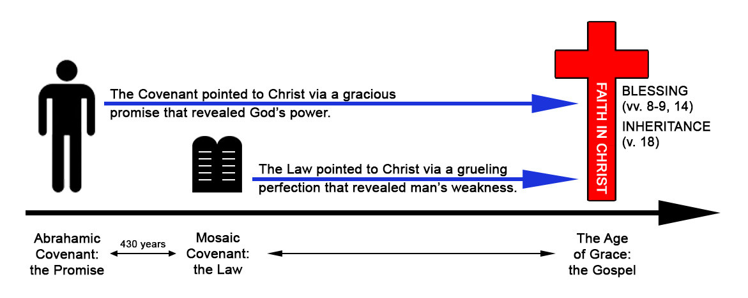
LESSON 7: “The Argument Continues” Date: October 26, 2014
TEXT: Galatians 3:15-22
INTRODUCTION
Galatians has been referred to as Diet Romans due to similarities in both its style and substance. Regarding style, Paul portrays the same logic and argumentation that he does in Romans; regarding substance, his concern is to similarly defend the gospel of grace alone through faith alone. In the previous lesson, Paul offered three reasons for the sufficiency of in salvation:
- the experience of the Galatians (3:1-5)
- the example of Abraham (3:6-9)
- the expiation of Jesus Christ (3:10-14)
In Galatians 3:15-22, Paul’s argument continues as he offers two additional evidences.
THE ESTABLISHMENT OF THE (vv. 15-18)
- The of the Covenant (v. 15)

- The of the Covenant (v. 16)

- The of the Covenant (vv. 17-18)

THE ESSENCE OF THE (vv. 19-22)
- The of the Law (vv. 19b-21)

- The of the Law (v. 19b)

- The of the Law (vv. 19c-20)

- The of the Law (v. 21)

- The of the Law (vv. 19a, 22)

- To prove the of every person

- To point to through faith in Jesus Christ

