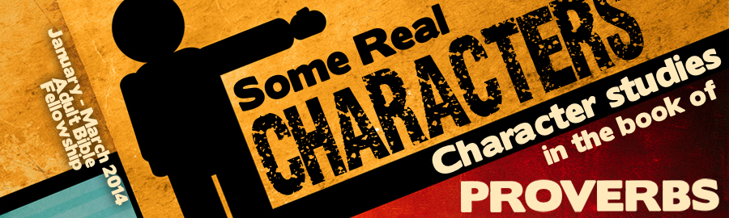
LESSON 7: “The Merciful” Date:
KEY VERSE: Proverbs 11:17 – “The merciful man doeth good to his own soul: but he that is cruel troubleth his own flesh.”
INTRODUCTION
The book of Proverbs is filled with gripping comparisons. Studying the characters portrayed in the book of Proverbs is often done best through a study in . For instance, Proverbs contrasts the rich and the poor; the virtuous woman and the harlot; the wise son and the fool. Today we will contrast the character of the “merciful” and the “oppressor.” We will see the difference between the person filled with “mercy” and the person filled with “cruelty.”
Before we come to grips with the character of the merciful and the merciless in the book of Proverbs, let’s look into Exodus 34 and remember that our God is a God of (Ex. 34:5-7). It is important to notice that the very first attribute that God reveals before He re-chisels the Ten Commandments and ratifies The Law is His attribute of “Mercy.”
The Christian who exhibits mercy is a Christian who exhibits the character of God. The book of Proverbs challenges the wise to be merciful! Proverbs presents the merciful and the merciless (or cruel) as polar opposites. Let’s take time to acquaint ourselves with these two diametrically opposite characters. We will begin by looking carefully at the Merciless.
THE MERCILESS
Society has many names for this monster. Psychologists call this one a sadist. Business people call this person a shark. Sports enthusiasts say this person is “highly competitive.” In Proverbs, the merciless are portrayed as simply lacking compassion. They feel no sorrow when others suffer. They seem to be unable to empathize with others.
THE OF THE MERCILESS (PROV. 12:10)

THE OF THE MERCILESS (PROV. 11:17)
- They oppress the (Prov. 14:31).
- They build themselves up by taking of others (Prov. 22:16).
- They have no for others (Prov. 22:22).
THE OF THE MERCILESS

THE MERCIFUL
When you find the word, “merciful,” or “mercy,” in the book of Proverbs, you should be aware that there are actually three different Hebrew words that could have been used to describe the character of the merciful.
HOW CAN A PERSON BE MERCIFUL?
- By diligently reading and applying God’s (Prov. 3:1-4)
- By treating all men (Prov.14:20-21).
WHAT HAPPENS TO A MERCIFUL MAN?
- The merciful does good to his soul (Prov. 11:17).
- The merciful is (Prov. 14:21).
- The merciful relationships (Prov. 16:6
- The merciful will find life, righteousness and honor (Proverbs 21:21).
- The merciful will always (Prov. 20:28).
CONCLUSION
There are two times that God uses the deepest and most passionate word for mercy in the book of Proverbs. The first usage speaks of the hypocritical mercy of the cruel. The second usage speaks of the holy mercy of God. That verse is Proverbs 28:13 — “He that covereth his sins shall not prosper: but whoso confesseth and forsaketh them shall have mercy.”
If you would know God’s loving mercy, you must honestly confess your sin. Might it be that you need to confess the sin of cruelty? Might it be that your wife, your husband or your children has seen little by way of mercy about you?

