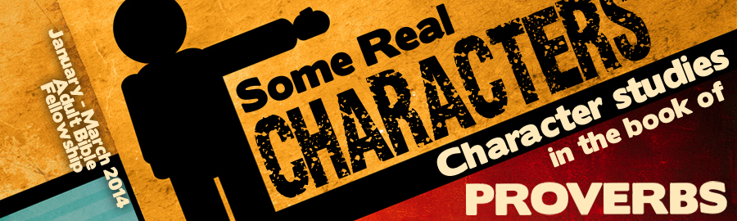
LESSON 5: “Friendship” Date:
KEY VERSE: Proverbs 27:17 – “Iron sharpeneth iron; so a man sharpeneth the countenance of his friend.”
INTRODUCTION
A friend is one who truly cares about the life and the interests of others. Therefore, the opposite of friendliness is _________________________.
Proverbs uses the word, “friend,” twenty-two times. In the mind of the author or the book of Proverbs, three different words describe the person that we simply call “friend.”
- A friend is someone who (Prov. 14:20; 18:24c; 27:6).
- A friend is someone who (Prov. 16:28; 17:9). The word portrays someone in charge of 1,000’s or a “chief person.”
- A friend is someone who (Prov. 18:24a; 19:7; 22:24).
When taken together, these words describe a friend as someone loved, respected and chosen. Care, trust and enjoyment are three vital ingredients in a good friendship.
Because God knows that “It is not good for man to be alone” (Gen. 2:18), we are encouraged to actively engage in finding friends. The book of Proverbs provides an excellent guide for those who would a friend and have a friend.
MAKING FRIENDS
Proverbs 18:24 is a very familiar verse, “He that hath friends must shew himself friendly.”
PRACTICAL TIPS —
- The friendly person . Real listening is an art. It requires that you stop, look, and listen.
- The friendly person . Talking about matters that interest others is a sure way to make friends. Engaging in conversations that draw out information from others rather than focusing on self is pathway to friendship.
- The friendly person . Frank Hamrick suggests that smiling requires self-forgetfulness, reflects warm-heartedness and relaxes nervousness.
SCRIPTURAL TIPS —
- The true friend overlooks the of others (Prov. 17:9).
- The true friend overpowers (Prov. 18:24).
- The true friend overcomes his (Prov. 22:11).
KEEPING FRIENDS
Our nation’s staggering divorce rate is ample evidence of our inability to keep friends. Proverbs stresses our need to maintain a right relationship with God in order to maintain a right relationship with others (Prov. 22:11). In order to keep friends, the book of Proverbs teaches us to incorporate the following traits into our lives:
- We must be careful in our (Prov. 6:1-3).
- We must be willing to sacrifice for one another (Prov. 17:18).
- We must be willing to (Prov. 17:9).
- We must be (Prov. 27:10).
- We must be in our advice (Prov. 27:6).
LOSING FRIENDS
There are specific character flaws that will cause the loss of friends.
- (Prov. 22:24)
- (Prov. 27:14)
- (Prov. 16:28)
- instability (Prov. 19:7)
Life will be marked by friendships (Prov. 28:7). It is by friendship that we are helped along the journey toward heaven (Prov. 27:17).

