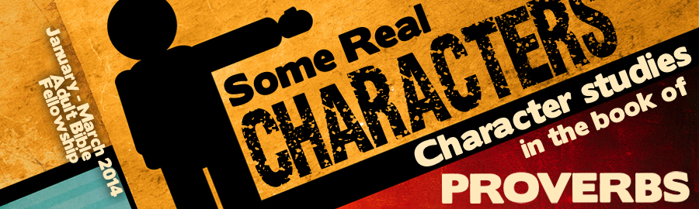
LESSON 4: “The Man of Anger” Date:
KEY VERSE: Proverbs 16:32 – “He that is slow to anger is better than the mighty.”
INTRODUCTION
One of the most significant studies in the book of Proverbs is the study of anger, contention, strife, and wrath. Thirteen different Hebrew words are behind these four English words. Anger and wrath are inner dispositions from which strife and contention are produced.
While our words “anger” and “wrath” may sound simple, the words that the author of the book of Proverbs originally used to describe these emotional conditions were quite complex. There are six Hebrew ideas behind the words simply translated, “anger” and “wrath” in our English Bibles.
- The flaring of the (Prov. 14:17, 29, 15:1, 15; 16:32; 19:11; 20:2; 21:14; 22:24; 27:4; 29:8, 22; 30:33) — This word is often used to portray God’s anger towards sin.
- A commotion filled mind (Prov. 12:16; 21:19; 27:3) — Those who are insane are said to have “gone mad.” This is the very picture frequently presented in the book of Proverbs.
- Something that is in or overflowing (Prov. 11:4, 23; 21:24) — When emotions exceed the need presented by a situation, they overflow.
- To be hot or (Prov. 14:17; 15:1, 18; 16:14; 19:19; 21:14, 27:4)
- To be (Prov. 25:23) — This is anger that is justifiable.
- To be , sad or depressed (Prov. 19:12)
Without question, the angry man is a complex character. He may rage like a snorting bull, completely lose his faculties, lose control, be quick to respond, indignant, or even depressed. The book of Proverbs contrasts the angry man with the man who is under control because God wants the wise to have control over their anger.
THE CAUSES OF ANGER
Proverbs suggests that there are at least four failures that often cause anger. By understanding these causes, we can learn to deal with our own anger and how to avoid sparking anger in others.
- Anger fails to avoid (Prov. 13:10; 21:24).
- Anger fails to offer soft answers (Prov. 15:1).
- Anger fails to be (Prov. 19:11).
- Anger fails to build (Prov. 21:14).
THE HARM OF ANGER
- Anger brings .
a. This pain may be physical (Prov. 14:29-30).
b. This pain may be emotional (Prov. 27:3).
- Anger makes difficult.
- Anger provokes frequent (Prov. 19:19).
- Anger destroys (Prov. 12:16).
- Anger leads to constant (Prov. 30:33).
- Anger provokes cruelty to others.
THE AVOIDANCE OF ANGER
The book of Proverbs teaches the wise to avoid allowing anger to dominate themselves and it also teaches the wisdom of avoiding those who are filled with anger (Prov. 21:19).
- Strife come (Prov. 29:22).
- Anger is (Prov. 22:24-25).
THE JUSTIFICATION OF ANGER
The book of Proverbs teaches us that anger is occasionally justified.
- When it turns away (Prov. 25:33).
- When God judges (Prov. 11:4, 23).
Proverbs 16:32 – “He that is slow to anger is better than the mighty.”

