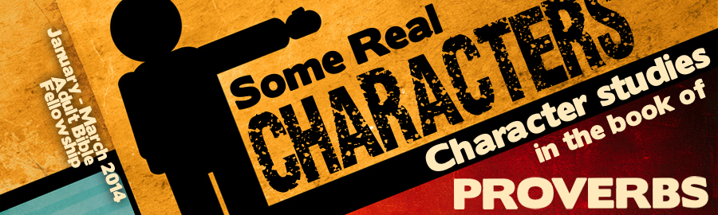
LESSON 11: “Rejecters: Comparisons that Count” Date:
KEY VERSE: Proverbs 1:22 – “How long, ye simple ones, will ye love simplicity? And the scorners delight in their scorning, and fools hate knowledge?”
INTRODUCTION
God’s comparisons and classifications are much more important than the comparisons and classifications offered by the world. As we study the book of Proverbs, we discover that the book is written to encourage those who are seeking wisdom (Proverb 1:1-6). Sadly, not everyone will receive the wisdom that God reveals. In Proverbs 1:22, God reveals that there are three classifications of revelation rejecters. Some are simple ones. Some are scorners. Some are fools.
Because the Hebrew title of the book of Proverbs means, , it is important that students of the book of Proverbs be diligent to find the comparisons that God has woven into this practical book. The authors of the book of Proverbs compare the rich and the poor, the righteous and the froward, the slothful and the diligent, as well as the proud and the humble. Proverbs 1:22 sets forward the wrong response of three kinds of people to the revelation of the Bible. This is a study that is especially important for parents and Christian educators!
THE SIMPLE
The “simple one” appears times in the book of Proverbs. The “simple one” in Proverbs is a person who is pliable. The “simple one” in Proverbs is a follower.
UNDERSTANDING THE SIMPLE
- They lack (Prov. 9:1-6).
- They are (Prov. 14:15).
- They are susceptible to mischief (Prov. 7).
HELPING THE SIMPLE
- Simple ones need to be offered (Prov. 1:4).
- Simple ones need to be surrounded by those who are (Prov. 21:11).
THE SCORNER
The “scorner” is spoken of times in the book of Proverbs. Scorners seem to mock or ridicule what is right.
UNDERSTANDING THE SCORNER
- Scorners will not (Prov. 13:1)
- Scorners do not desire counsel (Prov. 15:12).
- Scorners actually those who teach righteousness (Prov. 9:8).
HELPING THE SCORNER
- He is to be (Prov. 19:25).
- He is to be (Prov. 22:10).
- He is to be punished creatively (Prov. 19:29).
THE FOOL
The fool is one of the most frequently focused upon characters in the book of Proverbs. The fool is spoken of over times. In essence, the fool is a person dedicated to evil with an unabashed hatred of wisdom.
UNDERSTANDING THE FOOL
- The fool sins with (Prov. 14:16).
- The fool is beyond correction (Prov. 17:10).
- The fool has no for wisdom (Prov. 17:16).
- The fool will (Prov. 10:18).
HELPING THE FOOL
- The fool is to be excluded from (Prov. 13:20).
- The fool is beyond (Prov. 23:9).
THE WISE
The ultimate goal of the book of Proverbs is to produce wise sons (see chapter one). Three characteristics mark the character of the wise:
- He listens to wise (Prov. 1:5).
- He understands the the Lord (Prov. 2:1-5).
- He owns true (Prov. 8:11).
CONCLUSION
God’s comparisons and classifications are much more important than the comparisons and classifications offered by the world. Sadly, not everyone will receive the wisdom that God reveals. In Proverbs 1:22, we have met three kinds of revelation rejecters: simple ones, scorners, and fools. These characters are introduced in order to help those who would develop wise sons.

