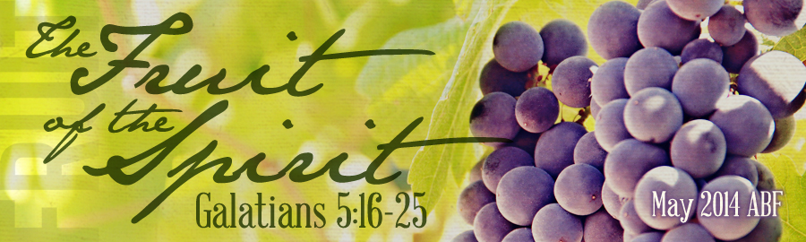
- The of Temperance
We live in a society today that is out of control , ,
, and .
- The of Temperance
You will never obtain self-control, until you yield control of yourself to the Spirit of God. Temperance is from all things forbidden and in things permissible.
- Physically: our (I Cor. 6:19-20)

- Mentally: our (Phil. 4:8)

- Emotionally: our (Prov. 25:28)

- The for Temperance
The way to is to surrender to the ! Someone has said, “The beginning of self-mastery is to be mastered by Christ, yield to Him.” S.D. Gordon wrote, “In every man’s life there is a throne, and when self is on that throne, Christ is on the cross. But when Christ is on that throne, self is one the cross.”
CONCLUSION
May I conclude with a word of hope and help for each one who desires to see spiritual fruit growing in your life. “Victory is within reach of every Christian, for every Christian has ‘crucified the flesh’ (v.24) and every Christian ‘lives by the Spirit’ (v. 25). Our task is to take time each day to remember these truths about ourselves, and to live accordingly. If we have crucified the flesh (which we have), then we must leave it securely nailed to the cross, where it deserves to be; we must not finger the nails. And if we live in the Spirit (which we do), then we must walk by the Spirit. So when the tempter comes with evil insinuations, we must round on him savagely, and say to him: ‘I belong to Christ. I have crucified the flesh. It is altogether out of the question that I should even dream of taking it down from the cross.’ Again, ‘I belong to Christ. The Spirit dwells within me. So I shall set my mind on the things of the Spirit and walk by the Spirit, according to His rule and line, from day to day.’” When we live with this mindset and daily yield ourselves to the Spirit’s control, even the humblest child of God can cultivate the fruit of the Spirit. May God produce a bountiful harvest of fruit in us for His honor and glory!
LESSON 4: “The Fruit of Faith, Meekness, and Temperance”
TEXT: Galatians 5:22-23 DATE:
INTRODUCTION
We have been walking through the Garden of God examining the fruit of the Spirit these past several weeks. The nine-fold manifestations of this singular fruit have been presented in triads. The first trio deals with our relationship upward to God. The second set speaks to our outward relationship with others. Today we will conclude our study with the final three which emphasis our internal self relationship.
Key to spiritual victory and vitality is to “walk in the Spirit” (Gal. 5:16). What does it mean to “walk in the Spirit”? It is allowing the of God to take the of God to make me more like the of God. How do I “walk in the Spirit”? By actively filling my mind with
and walking in to God’s revealed truth, therefore the Spirit of God to guide and direct me through His Word. What happens when I am “walking in the Spirit”? When I “walk in the Spirit” the sinful is (5:16) and the spiritual is (5:22-23). What is the fruit that God produces in us?
- Love: the determined act of the will that of self for the sake of others
- Joy: finding greatest delight in my and in Christ
- Peace: the of soul because I am rightly related to God and others
- Longsuffering: the ability to injuries inflicted by others without getting and
- Gentleness: kindness in actively at meeting the needs of others
- Goodness: moral and spiritual of life that afflicts the comfortably apathetic and comforts the afflicted around us
We will be working to define and develop the fruit of faithfulness, meekness, and temperance in our lesson today.
THE FRUIT OF (v.22)
Faithfulness is “integrity, honesty, loyalty, or trustworthiness.” It is being someone in whom complete confidence can be placed. This term means to be utterly reliable and true to your word. If I am Christ, others should be able to me.
- The for Faithfulness

- God faithfulness (Ps. 51:6)

- God faithfulness (Mt. 25:21)

- God faithfulness (I Cor. 4:2)

- The of Faithfulness
Our faithfulness should not be peripheral, or occasional, but steadfast. Our sense of faithfulness should not rest on another’s faithfulness, and cease when he or she is found unfaithful. Our faithfulness must have a hidden reserve which continues long after visible supports of it are gone. It must be modeled after God’s steadfast faithfulness.
- The of Faithfulness
If you are a child of God, faithfulness should characterize your life. You must seek to be faithful wherever you are and in whatever you do. What should we be faithful in?
- Faithful in the things (Lk. 16:10)
If you cannot be trusted with the things of life, you will be untrustworthy with the things of life.
- Faithful in the things
A faithful individual is the same in and , at home and church. Their and are well pleasing to God.
- Faithful in the things (I Cor. 10:31)
For a Christian, all things are because everything we do is to be for the of God.
  - Faithful to your (Eph. 5:22-6:4)

  - Faithful to your (Prov. 17:17)

  - Faithful to your (Heb. 10:25)
THE FRUIT OF (v.23)
Most people immediately equate meekness with . Meekness actually requires great strength.
- The of Meekness
The dictionary defines it as “gentle, submissive, tame, or yielding.” Meekness is not , but rather it is under control. John MacArthur identifies three primary attitudes that are linked to meekness in the NT. They are (1) a to the will of God; (2) ; and (3) a of others. Meekness then is the attitude of heart that accepts the Lord's dealings with us as good, perfect, and acceptable and is not open for dispute or resistance.
- The for Meekness

- The Savior’s (Mt. 11:28-29)

- The Scripture’s (Col. 3:12)

- The of Meekness (James 1:21-22)
- Meekness is having a heart (James 1:21)

- Meekness is having a heart (James 1:21)

- Meekness is having a heart (James 1:22)
Someone has said, “ without leads to ”!
THE FRUIT OF (v.23)
The word “temperance” means “ .” This is a of one’s desires. The word temperance means self-control in all things, and it was used to describe the person who had powerful passions but kept them under control. Temperance is the ability to pursue the
over the , rather than to be always
or .

