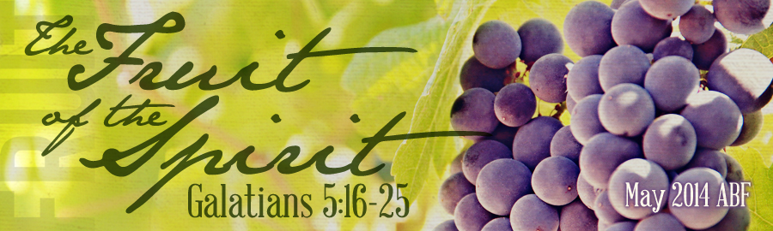
- Peace in (Col. 3:15)
Peace should be a of a godly person. The peace of God calms our anxious hearts and keeps us under control. A Spirit-filled and controlled believer will evidence the fruit of the Spirit which is peace. How can we cultivate this fruit in our lives? God has given us a three-fold plan for internal peace in Philippians 4:4-7.
- Peace Comes Through a (Phil. 4:4) – “in the Lord”
Peace is not the of problems. Peace is the presence of in the midst of your problems! You will never find peace looking for peace, you will only find peace when you look for Jesus!
- Peace Comes Through (Phil. 4:6) – “by prayer”
The antithesis of peace in your heart is in your head. Worry and anxiety choke out the fruit of the Spirit. The answer to the pressures and cares of life is not in the
but a . God says “don’t worry, !” We must turn our into (I Pet. 5:7)!
- Peace Comes Through (Phil. 4:6) – “w/ thanksgiving”
It is tempting to wallow in self-pity when things are not going our way. However, we must make the choice to rejoice, and the Lord even in the midst of problems in life. When your heart is filled with and your mind is filled with , your soul will be filled with !
CONCLUSION
As you examine your life do you find the fruit of the Spirit growing there? By “walking in the Spirit” we can experience both spiritual victory and vitality as the fruit of love brings about joy which yields peace.
In order to cultivate this fruit in our lives, we must be Word-filled believers. The Scriptures are the preeminent means of grace to the child of God. Reflection upon and obedience to the Word of truth yields Christian character and the fruit of the Spirit – love, joy, and peace.

LESSON 2: “The Fruit of Love, Joy, and Peace” Date:
TEXT: Galatians 5:22-23
INTRODUCTION
Paul has placed the dark backdrop of the works of the flesh to bring forth the beauty of the fruit of the Spirit. Fleshly, sinful works are what we naturally produce. Heavenly, spiritual fruit is what He supernaturally produces in us. Within this text there are characteristics identified to this singular fruit. It is not a string of individual pearls, but one, multi-faceted diamond we are examining. Or in botanical language, this is a singular orange that we are dissecting segment by segment. We will be studying these nine graces in three sets of three over the next few weeks. These triads have been noted to deal first with our relationship to (love, joy, peace), second with our relationship to (longsuffering, gentleness, goodness), and finally with our relationship with (faith, meekness, temperance). Today we concentrate on the first three in the list that aid our relationship toward God. We will see that walking in the Spirit yields the fruit of the Spirit: love, joy, and peace.
THE FRUIT OF (v.22)
It has been said that love is the from which all the other virtues of spiritual fruit grow. “Love is not one virtue among a list of virtues, but the and of what it means to be a Christian” (Ryken).
- The of Love
What distinguishes biblical love (agape) from all others is its
nature. It is a love that gives and gives expecting nothing in return. It is of self for the sake of others, even for others who may care nothing at all for us and who may even hate us. It is not primarily a but a determined act of the , which results in determined acts of self–giving.
- The of Love (I Cor. 13)
First Corinthians 13 is often called “the love chapter”. In it we discover the most comprehensive biblical description of the fullness of love. It is as though Paul shines love through a prism and upon the pages of Scripture we see the spectrum of love with all its colors and hues. And each ray gives a facet and property of the demonstration of love. These descriptors do not focus on what love
so much as on what love and do.
- The of Love (Rom. 5:5)
Remember “love” the fruit of the Spirit! It is not a work of the flesh (something you produce), it is the fruit of the Spirit (what God produces in you). We must allow the Spirit of God to have control so that self-love and sacrificial love . We need to allow God to love others through us.
THE FRUIT OF (v.22)
The word “joy” occurs more than times in the Bible. The word “rejoice” is used some times. So over times we are told to be joyful and rejoice.
- The to Joy –
The world may seek , but the Christian must seek joy! Someone has said, “Joy is to be glad even when your circumstances are bad”. As a believer, we can have joy at all times when we live in the reality that God is always in control and consciously choose to trust Him. Joy is the spiritual response of
knowing God me, and I, therefore, find greatest in my relationship and position in Christ.
- The for Joy
We recall that joy is the fruit of the Spirit and can only be produced in us through yielding control to Him. At the same time the Bible
us to be joyful. Philippians 4:4 says, “Rejoice in the Lord alway, and again I say rejoice”. Paul was in prison when he wrote those words. He understood that rejoicing was a decision. Each of us, by the power of the Spirit, must make the to !
- The of Joy
Remember this is a fruit of the Spirit. It is not something that is natural, but supernatural. It is not something we work up, but something God works in and through us. We want to cultivate the fruit of the Spirit which is joy by making the choice to rejoice. As a Christian, what do I have to rejoice in?
- Rejoice in
- Rejoice in
- Rejoice in
THE FRUIT OF (v.22)
The world will never have true peace until the of returns to rule and reign, but believer’s can know personal peace as the Spirit has control. This word peace is parallel to the Hebrew word
meaning “well being, or wholeness”. Peace, then, is the of soul that we are rightly related to and . Scripture speaks of three types of peace that a believer can experience.
- Peace with (Rom. 5:1)
By faith in Christ we are justified before God and granted eternal peace. This restored relationship with God is foundational to experiencing true peace. You can never have peace within or peace with others until you have peace with God. Jesus, peace, but Jesus and peace!
- Peace with (Rom. 12:18)
Jesus taught his disciples, “Blessed are the peacemakers; for they shall be called the children of God” (Matt. 5:9). As children of God, we ought to be the in our human relationships. There are times where as much as we desire peace and tranquility, it is unattainable. However, we should not be the ones who are unwilling to work at resolving the problem in order to have peace. If it is within your power to put the issue to rest, do so. Be willing to
to .

